Analysis

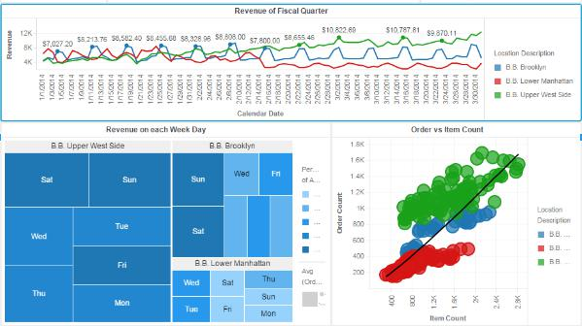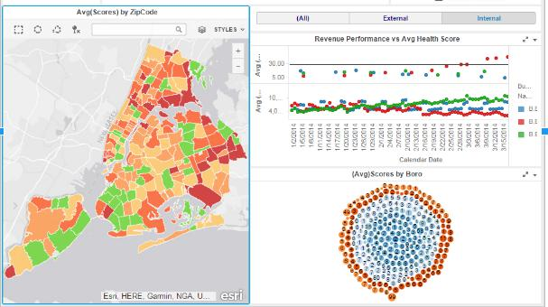

The line chart helps to know about the growth and fall during given fiscal quarter at the three different locations. The Revenue increases in the Upper West Side and decreases in the Lower Manhattan. The heat map shows that the Revenue is highest on the weekends. In the bubble chart, there is a large difference between item count and order count in the location Lower Manhattan. The reason behind this is the fall in revenue at this location.

In the second worksheet, we are able to analyze performance with the help of the Health Inspection Score, where we can see how the poor average health inspection score in Lower Manhattan affects average revenue in a negative way.

What more could have been done

1.Average Score by Boro visualization to highlight the Map in Sheet

2. A barchart to show the correlation between health-grade, violations, revenue.